|  |  |
| --- | --- |
| logo | |
|  |  |

**EELA Conference Bucharest**

**Minutes of the General Assembly**

**of 10 June 2023**

1. **Welcome and opening**

Klaus-Stefan Hohenstatt, the Chair and Anna Jerndorf, the Vice-Chair of EELA, opened the General Assembly and warmly welcomed all attending members of EELA. On this occasion, the Chair informed the Assembly about the development of the number of members:

Number of EELA members as of 1 January 2023: 1,392

European countries currently represented in EELA: 34

1. **EELA Board Elections 2023**

The Vice-Chair, Anna Jerndorf, announced the election process of the EELA Board members for the following countries:

Germany

Romania

Iceland

Sweden

Cyprus

England & Wales

Italy

Luxembourg

Northern Ireland

Scotland

Slovenia

The **election results** were as follows:

Germany: Kara Preedy

Romania: Corina Radu

Iceland: Jón Sigurðsson

Sweden: Anna Jerndorf

Cyprus: Nicos Panayiotou

England & Wales: Juliet Carp

Italy: Valeria Morosini

Luxembourg: Pierre Elvinger

Northern Ireland: Gareth Walls

Scotland: Joan Cradden

Slovenia: Petra Smolnikar

1. **Report of the Board 2022/2023**

The Chair Klaus-Stefan Hohenstatt and the Vice-Chair Anna Jerndorf presented the activities of the Board. They reported on the following Board meetings which took place on:

* 3 October 2022 (Bucharest)
* 3 February 2023 (Paris)
* 26 May 2023 (virtual)

1. **EELA/ERA Annual Seminar on European Labour Law**

The seminar will be held in Brussels, on 24 November 2023. EELA memebrs are invited to participate.

1. **Approval of the EELA Accounts for the year 2022**

The General Assembly approved the **2022** accounts:

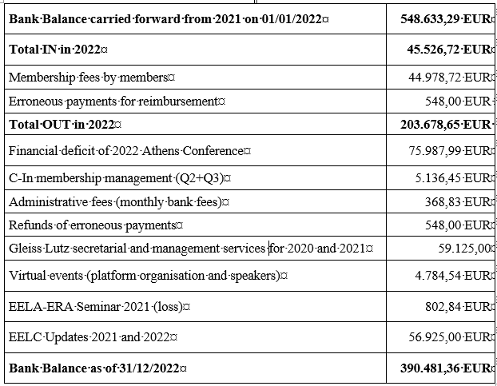

1. **Any other issues**

No further topics were discussed.

1. **Closing**

The Chair Klaus-Stefan Hohenstatt and the Vice-Chair Anna Jerndorf invited Jón Sigurðsson, EELA’s Board member from Iceland, to give a presentation about the coming EELA annual conference to be held in Reykjavik on 6 - 8 June 2024.

The Chair Klaus-Stefan Hohenstatt and the Vice-Chair Anna Jerndorf closed the General Assembly.

Bucharest, 10 June 2023

Klaus-Stefan Hohenstatt Anna Jerndorf

Chair Vice-Chair