|  |  |
| --- | --- |
| logo | |
|  |  |

**EELA Conference Reykjavik**

**Minutes of the General Assembly**

**of 8 June 2024**

**I. Welcome and opening**

Anna Jerndorf, the Chair opened the General Assembly and warmly welcomed all attending members of EELA. On this occasion, the Chair informed the Assembly about the development of the number of members:

Number of EELA members as of 1 January 2024: 1,473

European countries currently represented in EELA: 34

**II. EELA Board Elections 2024**

The Chair announced the election process of the EELA Board members for the following countries:

Belgium

Northern Ireland

The **election results** were as follows:

Belgium: Sophie Maes

Northern Ireland: Rob Tubman

**III. Approval of the EELA Accounts for the year 2023**

The General Assembly approved the 2023 accounts:

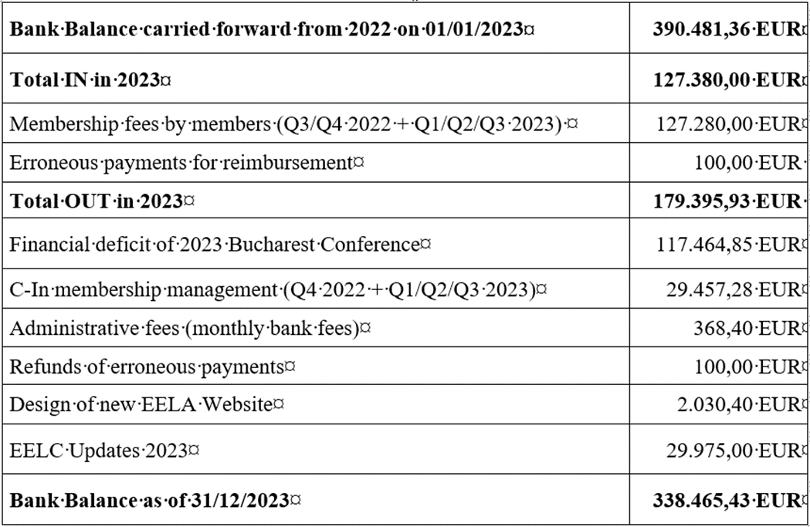

**IV. Constitutional Amendment regarding the annual Membership Fee**

The proposed wording of the amendment was approved and shall read as follows:

***9. Membership Fees***

***9.1 Membership fees are payable at the beginning of each calender year. The Board shall be entitled to increase the membership fees up to a maximum of Euro 150 per member or reduce the membership fees at own discretion. Increases beyond this amount are subject to approval by the next General Assembly.***

The new constitutional wording shall be published on the EELA website.

**V. EELA/ERA Annual Seminar on European Labour Law**

The Seminarwill be held in Brussels, on 22 November 2024. EELA mememrs are invited to participate.

**VI. Closing**

The Chair Anna Jerndorf invited Juliet Carp, EELA’s Board member from England & Wales, to give a presentation about the coming EELA annual conference to be held in London on 12 - 14 June 2025.

The Chair Anna Jerndorf closed the General Assembly.

Reykjavik, 8 June 2024

Anna Jerndorf Dusan Nitschneider

Chair Vice-Chair